**[ Beginner & Low Kyu Guidance (2) ]**

As mentioned in the last part, Beginner and Low Kyu refer to players who are:

**Beginner – below 15 kyu**

**Low Kyu – 6~14 kyu**

and the Keywords & Suggestions for Low Kyu players are:

|  |  |  |
| --- | --- | --- |
|  | **Keywords** | **Suggestions** |
| **Low Kyu** | Skill Training  Territory & Efficiency | Play on bigger boards  Traditional Openings  Tsumego Training  Play slow games online |

**Tips for Low Kyu Players**

At this stage it is easy for players to win games against beginners; however, when you face stronger opponents you stand little chance to win. Out of nowhere your groups die; or it’s simply your opponent gets way more territory than you without a single fight. If what I just said works for you, then you probably need to consider some serious skill training, and do some serious thinking about the rules of the game – the relationship between territory and efficiency.

**Keyword 1. Skill Training**

To lose easily is not a way to keep your spirit up high; and now that you’ve learned how to capture stones and how to properly complete a game, now you need to practice your skills. Practice always makes perfect.

However, as you practice, there should be emphasis on certain skills – the skills that can help you better win the games. Endgame skills do not influence the game so much if a fight happens and the game ends. A bad opening also casts really bad effect on where the game is going. Therefore, training on opening and tsumego should work better than endgame training. Besides, to have some serious opening training you need to play on a bigger board, so that’s when you need to give up your tiny 9x9 board and turn to 13x13, eventually 19x19 boards.

A normal game consists of different stages. Generally there are three: opening, midgame and endgame. Different training techniques are required to improve your performance on different stages.

**1. Opening**.

When black makes move 1, the opening starts. This is the part where extensive research has been done, and where the evaluation of the game is most abstract. In the opening stage, both sides attempt to occupy the “open fields”, and in midgame stage they’d put up fights for territory.

Unlike chess, there are way too many choices for Go openings. Except the classical ones, the opening could differ so much that you normally can’t find two games that share the first 20 moves. There are three protocols for opening:

**(1) Play on corners, then edges, then in the middle**. The first 4 moves of almost every game is on the corners, and that happens for a reason. Actually, Go is a game where the one with more territory wins. Since the moves made by two sides are equal, to obtain more territory, you need better efficiency. So you should always make moves that are highly efficient, or force your opponent to make moves that are inefficient.

The efficiency to occupy territory differs with the position of stones. Let’s take a look at the board in Figure 1, and compare the moves it takes for 6 points.

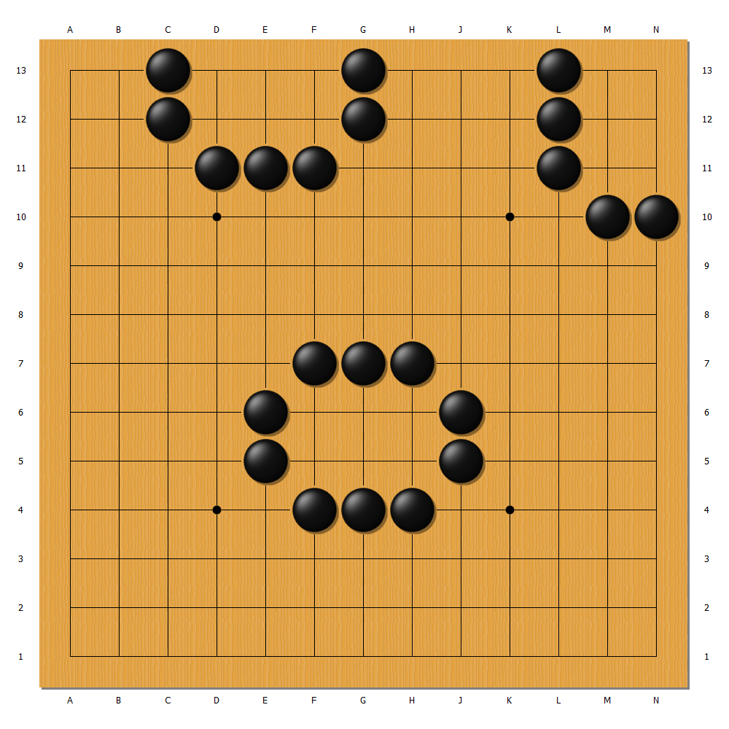

**Figure 1.** The moves it takes for 6 moves is different. On corners you need 5 moves; on edges you need 7; in the middle you need 10.

The difference between the three positions is that the edges of the board can help you enclose territory. It’s the same as building fences for your garden – if your garden is located right adjacent to your house, then one wall of your house can be used as the garden boundary, thus only three walls are required. To build a 2x3 territory, which gives you 6 points, you need to build 4 “walls” if you start in the middle. You only need 3 walls if you start on one edge, because the edge itself is a natural wall. On corners two edges are available, which saves you 2 walls, and produces much higher efficiency.

Therefore, always start at corners, and then edges.

**(2) Play in the open field.** The open field means the unexplored field. It means possibility and usually goldmine. On a Go board, the open fields are normally places around which few stones exist, like the black move A in Figure 2. Move A is a good one. Compared to that, the white move B is playing in a spot where many stones already exist. Such moves do not add much territory or control over an area for white. So move B is an inefficient move, which makes it unacceptable.

Always remember that playing on the open field grants you higher efficiency or control over more area.

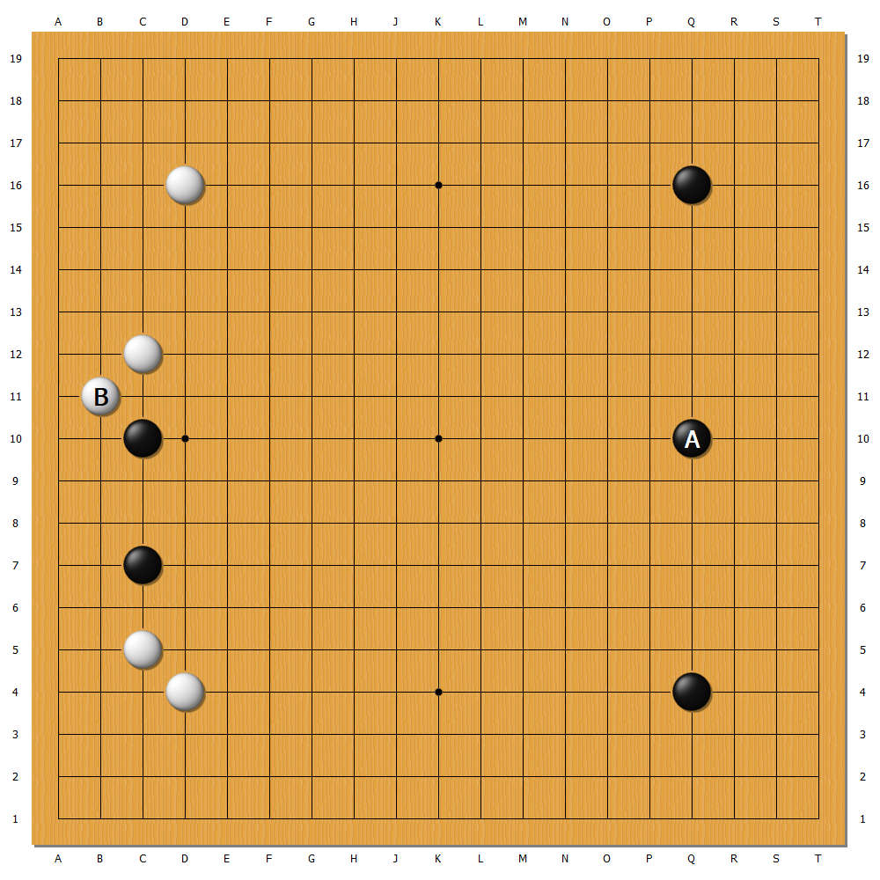

**Figure 2.** Always play in the open field.

**(3)** **Opening is flexible, and best learned in actual games.** Over the years Go players have developed many classical openings which have been applied to numerous high level games.As beginners it’s quite helpful to memorize some classical openings and put them into use in your actual games. However, when you learn about the openings, you should always ask yourself why this move is good. After you try it out for some games, your understanding improves. But always remember that opening is flexible – there is no correct answer for opening moves. All rules apply, as long as the move works for you.

Here are some classical openings on a 19x19 board. I will talk about the classical openings exclusively on one chapter, after finishing all the introduction.

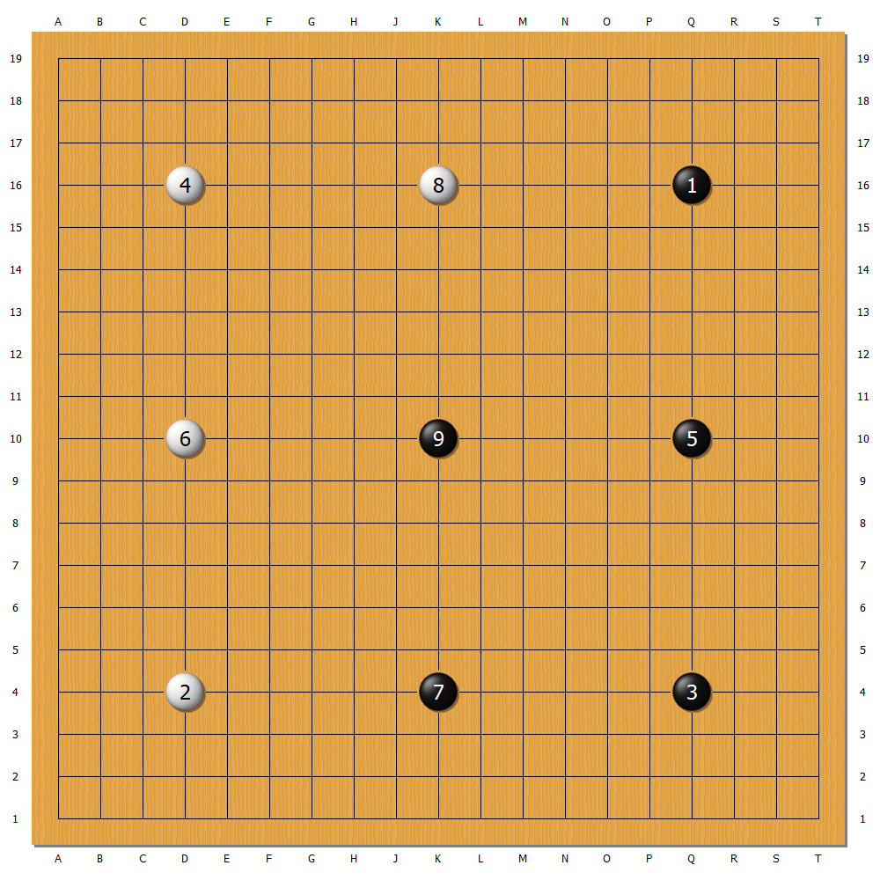

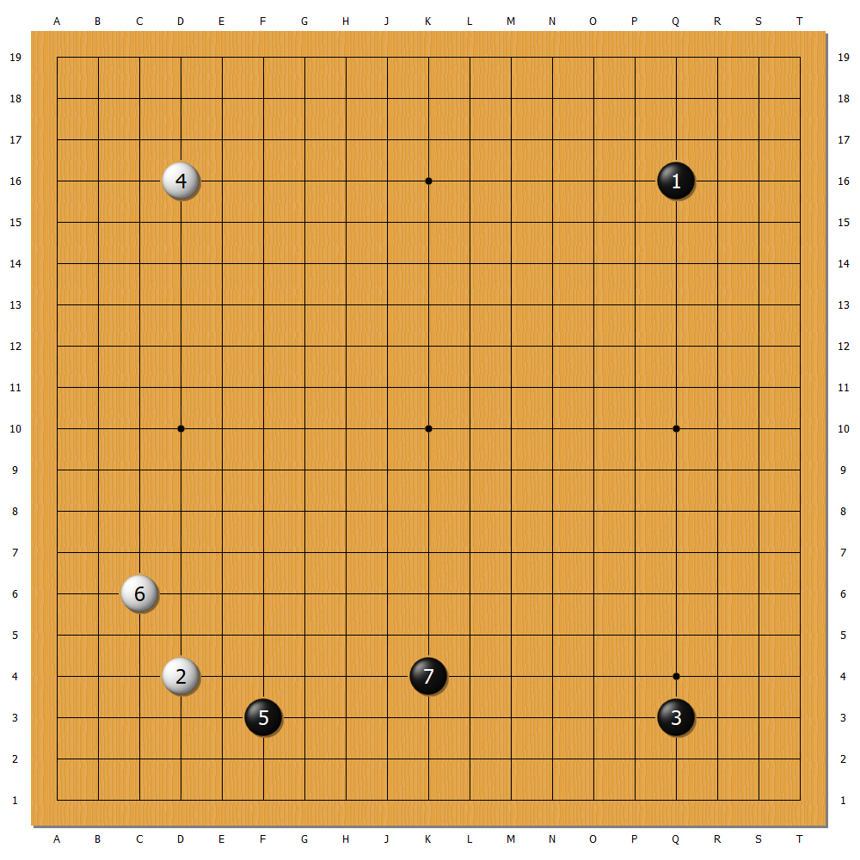

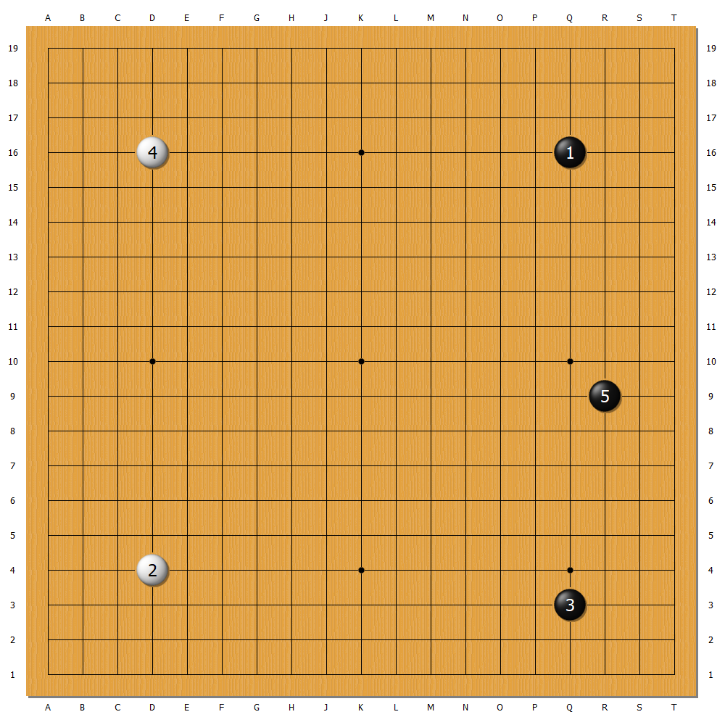

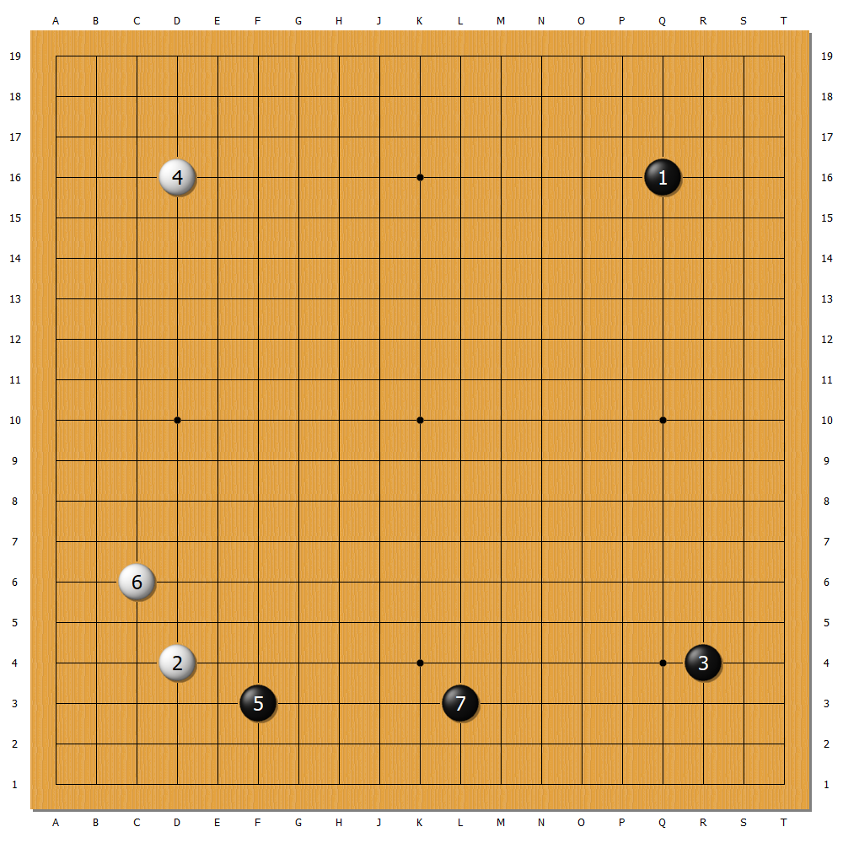

**2**. **Midgame**.

**3. Endgame**.